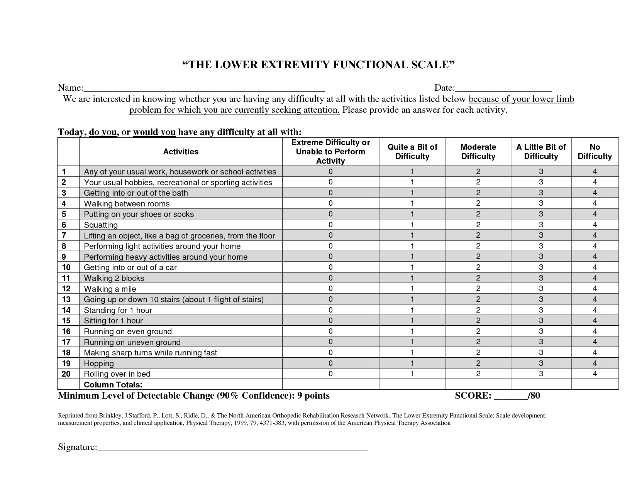NAME:_________________________________________________ DATE:____________________________________

We are interested in knowing whether you are having any difficulty at all with the activities listed below because of your upper limb problem for which you are currently seeking attention. Please provide an answer for each activity if possible. If you typically do not perform an activity, **please leave blank**